Annotated Unit Plan Template
Understanding By Design Model
(Revised: October 2020)

Title of Unit | Multiplication | Grade Level | Three
Subject | Mathematics | Time Frame | 6 - 7 Days
Developed By | Makenna Morrison + Hannah Magnusson
Stage 1 - Identify Desired Results

Saskatchewan Curricular Learning Outcome(s)
What relevant goal(s) will this unit address?

N3.3 Demonstrate understanding of multiplication to 5x5 and the corresponding division statements including:
- Representing and explaining using repeated addition or subtraction, equal grouping, and arrays
- creating and solving situational questions
- modelling processes using concrete, physical, and visual representations, and recording the process symbolically
- relating multiplication and division

Essential Questions
What provocative questions (one or two) will foster inquiry into the content?
What are the math multiplication strategies?
How can these multiplication strategies be used? How are they helpful?
Knowledge:  What math knowledge will students acquire as a result of this unit? (think of nouns – chunks of knowledge) |  | Skills  What math skills will students acquire as a result of this unit? (think of verbs – what will you be able to observe students doing)
Students will know…  - the different multiplication strategies  - how to use each multiplication strategy  - how to write and solve multiplication statements |  | Students will be able to…  - multiple up to 5  - organize their personal strategies  - observe and describe multiplication statements  - represent and create multiplication strategies  - apply and solve multiplication strategies

Stage 2 – Assessment Evidence (excerpt)

Mathematical Misconceptions (or errors) [use resource posted on UR Courses]
What kind of mathematical misconceptions might students display during this unit? What can you, as a teacher, do to specifically address these?

A misconception students might have is when generalizing about the product. This would be if students incorrectly generalize that the product of two numbers is always greater than the use of the same two numbers. These students are stymied by expressions like 5x1, 5x0, and 2x2.
As the teacher I would address these errors by using visuals to make sure the students can see that the product of two numbers won’t always be greater than the same two numbers. To work on this, I would take extra time to focus on multiplying by 0 and 1.
As the teacher I will be aware of the contradictions of telling the students that multiplication makes things bigger and am careful with their generalizations.

Evidence
Through what evidence – student work samples, observations, quizzes, tests, self-assessment or other means – will students demonstrate achievement of the desired results of this unit?

Students will demonstrate achievement through
- math journals
- worksheets
- hands on experiences (centers)
- exit slips
- homework sheets

Stage 3 - Learning Plan (Stage 3)
Where are your students headed? Where have they been? How will you make sure the students know where they are going? |  | The students will be headed to using more strategies as this unit goes on. After this unit the students will move into more lessons to practice these strategies than into division.  They will have been using repeated addition, equal grouping, arrays, and skip counting to solve multiplication statements. In this unit they will be doing multiplication up to 5 times.  To make sure the students know where they are going we will begin by creating a big poster in lesson 1 of all the strategies that they will be learning to solve multiplication. The students will be able to review back to the poster to remember what each strategy is but also to see what one is coming next.
How will you hook students at the beginning of the unit and engage their interest? |  | To hook the students at the beginning of the unit I will start by reading them a short story that relates to multiplication, and learning multiplication. The story I would read is Amanda Bean’s Amazing Dream by Cindy Neuschwander. It is an engaging story about a young girl who has a dream about why she needs to learn multiplication.
What events will help students experience and explore the big ideas and essential questions in the unit? How will you equip them with needed skills and knowledge? |  | The events that will help students experience and explore the big ideas in this unit will be the videos and visuals, hands on activities, manipulatives, and worksheets. The class discussions will also be an event that helps students explore the multiplication strategies.  To equip the students with needed knowledge and skills I will provide them with the resources and the activities to learn multiplication. I will make sure to find engaging activities and videos that the students will find interesting and want to learn more.
How will you cause students to reflect and rethink? How will you guide them in rehearsing, revising, and refining their work? |  | To cause students to reflect and rethink math journals, exit slips, stations, and homework will be used to give the students time to review what they have learnt. To guide them in rehearsing, revising, and refining their work I will make sure students are given a fair amount of time to complete all of the tasks that I ask of them.
How will you help students to exhibit and self-evaluate their growing skills, knowledge, and understanding throughout the unit? |  | To allow the students to self evaluate themselves the students will write in their math journals. Students will be able to go back to their journal to see where they started to where they have come to. They also will be given time to add to their math journals about things they have learned, are still struggling with, and want to know more about. Also, to all the students to exhibit their growing skills and knowledge they will be given time to think, pair, and share their ideas. This will allow the students to think about what they have learned but also what others have to say about this topic during shared time.
How will you tailor and otherwise personalize the learning plan to optimize the engagement and effectiveness of ALL students, without compromising the goals of the unit? |  | I will tailor and personalize the learning plan to ensure all students are engaged and learning by using different learning styles throughout the unit. I will incorporate styles like videos, manipulatives, worksheets, group work, class discussion, and teacher directed information. Using all of these different learning styles will allow for all students to engage and the unit plan will be effective without compromising the goal of the unit. To ensure all students are interacting and taking part I would make sure to assign the groups students will be working with so students can be successful in their group activities. I will also personalize the unit plan by using real life examples that the students can connect to but to also use the students when explaining an example. (using them as manipulatives in activity/lesson 3)
How will you organize and sequence the learning activities to optimize the engagement and achievement of ALL students? |  | I will organize the sequence of learning activities by having them each build on each other and relate to the last activity that was learned and explored. This will allow all of the students to see the connections between the activities that they are taking part in. I will also organize them by making sure all lessons are engaging and start with a good hook so all students can begin by engaging in the lesson. I will also use more than one learning skill to allow for all students to have the greatest amount of achievement.
How will we get there?
Instructional Plan – activities:
Consider using:  Mini-lessons  Multiple Intelligences  Models  Manipulatives  Rich problems  Math journals  Games  Stations  Literature  Integration with other subject areas  Projects  Homework  Resources:  Teacher’s guide  Textbook  Technology  Equipment  Books  Strategies:  T-chart  Think/Pair/Share  KWL  Drama  Connections | Activities/Lesson 1  Source of activity: Strategies for multiplication  Objective(s): (e) Apply and explain personal strategies for determining products and quotients  Hook: begin by reading Amanda Bean’s Amazing Dream  Brief description of activity: Begin with teacher explanation on all strategies than create stations of each strategies that the students work at/explore.  Strategies:  - repeated addition  - the students will receive a worksheet that has a visual representation on it of blocks in groups. They will then have to write out the repeated addition number sentence. When they have that they will then make it into a multiplication number sentence. They will be given a set of manipulatives like cube blocks to allow them to explore the question hands on. Example of what we would give them https://www.pinterest.ca/pin/262897696971114871/  - equal groups or sets  - Print off different multiplication questions for the students. Each student will get close to 25 manipulatives for themselves. They will have to look at the equation given to them and group their manipulatives in how they would be multiplied together. For example, if I gave them 5x5, they would have to make five groups with five manipulatives separated. More ideas can be found here https://www.twoboysandadad.com/2017/11/3-ways-teach-multiplication-concept.html  - an array  - The students will be at a table with a bunch of different puzzle pieces. The first puzzle piece will have a repeated addition number sentence, then the second will have an array visual and the last one will have the multiplication number sentence on it. students will have to find the puzzle pieces that go correctly together. they may work together or by themselves. They will also be given a blank worksheet to record their answers on or they can draw out what they see. More ideas can be found here https://missgiraffesclass.blogspot.com/2015/07/how-to-teach-arrays.html  - skip counting  - The students will all get multiple sets of charts with different easy to skip counting, either by 2’s, 3’ s, or 5’s. The charts will be laminated so if they mess up it could easily be erased. They will either work individually or together as a group to practice skip counting. After they have got the hang of this they will be given a blank chart and they will have to fill in the missing numbers corresponding with the given skip counting method. More ideas for skip counting can be found here https://www.aplusteachingresources.com.au/teaching-skip-counting/  Assessment: Math journals: The students will each be given their math journals at the end, when they have completed all the centers. They will be asked to write down what they have learned, what they struggled with understanding and what they would like to know more about or get more examples of. They will be given the last 10 minutes of class to work on this and will hand them in for the teacher to evaluate and see what still needs to be worked on and what they feel most comfortable with using.  Activities/Lesson 2  Source of activity: Repeated addition/number sentences  Objective(s): (c) explain and represent concretely, pictorially, orally, or physically, as well as symbolically, the relationship between repeated addition and multiplication and relationship between repeated subtraction and division  Hook: Watch this video with the students and pause at times to clarify what is going on. https://www.youtube.com/watch?v=ZpbYgpLqZno  Brief description of activity:  Introduction: present a repeated addition problem using showing several addends. (e.g. 6+6+6+6+6+6+....) explaining to the students we are going to figure out a way to solve this addition sentence easily. ask them to identify what they see in the number sentence, trying to elicit the response that sees adding the same number over and over.  Modeling: explaining to the students they will be learning about multiplication and the group size must be the same for multiplying. explaining that I have a large box of chocolates to share with my friends and I want to know how many I have. count by twos to find out how many I have. begin by putting together groups of connecting cubes, putting three of four in each group to show the students. ask them to examine first if each group has the same amount. demonstrate that we put the items in equal groups of easy numbers like groups of two.  Hands on Practice: next the students will be given a set of counters or other manipulative to create number sentences with the teacher. The teacher will say a number sentence and the students will create the model (e.g. 2+2+2+2+2+2 or 4+4+4+4 or 3+3+3+3+3+3). The students will be working with approximately 50 counters each. also, it is important to use numbers that allow students to skip count easily. using skip counting skills will support their understanding of multiplication in later lessons addressing the big ideas of equal groups for multiplication. If you want to challenge the students you can switch from saying the number sentence to creating a model and the students must record the number sentence using individual paper and pencil. the students should solve the number sentences during each step. students were using skip counting skills and knowledge of doubling numbers to find the sum of these number sentences. encourage the students to work in pairs to solve and share strategies with each other including drawing and building models with manipulatives.  Try it yourself: working in partners or a group, the students take turns going back and forth as the builder using the manipulatives and as the writer recording the number sentences. students use a spinner or a dice to determine the different number of addends to use for each repeated addition sentence. students use five-sided dice to get their numbers. This sets the number so that students are working within the guidelines of products up to 50. Using the dice creates an element of chance and eliminates the building of a pattern. Other things that could determine the numbers are, cards, dominoes and numbers written out on pieces of paper. The students record their sentences on worksheets and solve the problems together. students use blank paper to solve the problems including using repeated addition.  Wrap up: students will explain which groups are easier and which are more difficult to solve for repeated addition and explain their reasoning. the students in partners show and explain how they solved two of the repeated addition problems they completed. they may use manipulative, drawing or verbal explanations. “We solved this problem by using_______because________”. This will allow the students to use what is most comfortable for them. other students may ask questions about their strategy, so they are encouraged to explain the strategy they are most confident in using.  Assessment: Exit slip.  Questions for the exit slip:  - Was it easier to use manipulatives or finger counting?  - What is one thing you learned today?  - What is one thing you want to get better at?  Activities/Lesson 3  Source of activity: Equal grouping  Objective(s): (b) observe and describe situations relevant to self, family, or community that can be represented by equal sharing or grouping and write and solve a division statement for each situation  Hook: Watch this video with the students and pause to explain when students seem confused or need a review. https://www.youtube.com/watch?v=LD4zp8ruvaI  Brief description of activity: class discussion on equal grouping, use the students to break them up into equal groups to solve a multiplication fact together. Students play online game on multiplication grouping  Introduction: Begin by explaining the grouping strategy to the students. On the board write the multiplication statement 3x4. Ask the students if they have any idea how 3x4 would look as a picture? After the students answer, draw 3 big circles on the board. Explain to the students if the 3 is the number of groups than the 4 tells you how many go into each group. Then draw 4 stars in each circle. Count with the students the amount of stars they see. Now relate this back to lesson 2. Use repeated addition underneath each circle (4+4+4=12)  Modeling: use students to model an example. Use hula hoops or any other equipment to make a circle on the floor for the students to see. Now using the same example take 4 students and put them into the first group (hula hoop), take 4 more and put them into the second group (hula hoop), then take 4 more students and have them stand in the last group. Have all the students see that there are 3 groups with 4 students in each group. Now walk to the first group and say if this is four and then walk to the second group and say this is four more how many do we have? the answer will be eight and then walk over to the 3rd group and say if we have those 8 and add on these 4 how many do we have now? 12 so 3 groups of 4 students in each equals 12 students.  Hands on Practice: now split the students into groups of 3 to work with manipulatives to represent the example questions.  Worksheet with example questions to give students to work on: 1 x 3, 2 x 2, 3 x 2, 4 x 5, 5 x 2  Try it yourself: now the students will play the math online game to practice what they have just explored  https://www.khanacademy.org/math/cc-third-grade-math/intro-to-multiplication/multiply-with-groups-of-objects/e/meaning-of-multiplication  Wrap up: bring the students all back together and finish with a full class activity. On the board bring up pictures of equal groupings and work with the class to create the multiplication sentence that goes with each picture. After the activity review with the students.  Assessment: Homework (take home game sheet) Before assigning the students with this homework game explain with the students how to play. They can play with a family member or by themself. One person will roll both die and the other person will write the statement out and draw the equal groupings. At the beginning of the next day the students can share their equal groupings game results.  The students will also be given time to think/pair/ and share.  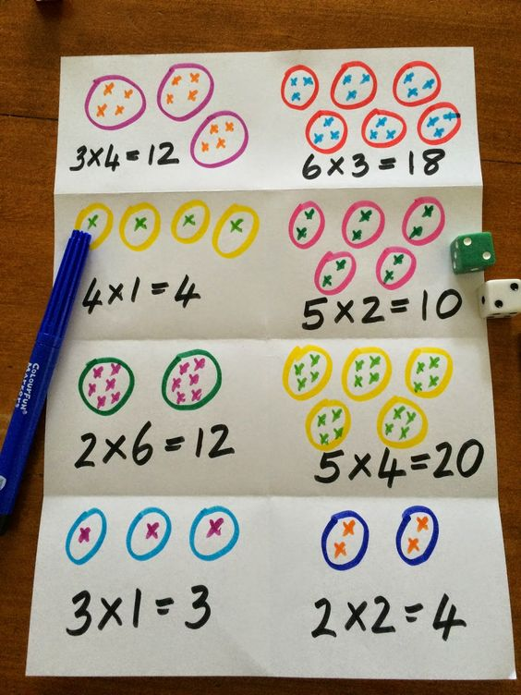

From: Wiggins, Grant and J. Mc Tighe. (1998). Understanding by Design, Association for Supervision and Curriculum Development
ISBN # 0-87120-313-8 (ppk)
Full Lesson Plan
(this includes the activity that you will present to peers in class)

LESSON DESIGN Planning Template (V2):
Based on the Ideas of Madeline Hunter and Barrie Bennett’s Beyond Monet

Title of Lesson: Multiplying using arrays | Subject & Grade: Math grade 3
Topic: Multiplication | Designer(s): Hannah and Makenna
Original Source(s) of activities:
https://www.commonsense.org/education/lesson-plans/draw-and-tell-multiplication-arrays

Outcome (and appropriate indicators) from Saskatchewan Curriculum | N3.3 Demonstrate understanding of multiplication to 5x5 and the corresponding division statements including:  - Representing and explaining using repeated addition or subtraction, equal grouping, and arrays  - creating and solving situational questions  - modelling processes using concrete, physical, and visual representations, and recording the process symbolically  - relating multiplication and division  indicators:  (h) relate multiplication and division orally using concrete, physical or pictorial models, including repeated addition/subtraction and array/dimensions  (j) create and solve a situational question that relates to a given symbolic multiplication or division statement  Cross curriculum  CP3.7 Create visual artworks that express ideas about the natural, constructed, and imagined environments.  (b) Develop a plan to visually explore selected question(s). (e.g., observe and draw, gather research information, imagine and paint).  CR3.2 View and respond to grade-appropriate visual and multimedia texts (including videos, cartoons, illustrations, diagrams, charts, maps, and posters) explaining reactions and connections as well as visual features that convey humour, emotion and mood.  (e) Identify design, layout, and other features (e.g., colour, bold typeface, and sound effects) that help to understand grade-appropriate visual and multimedia texts (including First Nations and Métis resources).  (i) Identify and discuss the key visual features such as colour, line and size of an illustrator’s styles and how they relate to the print text and add to or supplement words

Why these activities? (How are they appropriate? How are they effective?)
These activities are appropriate because they are at the students grade level and they will be using knowledge that they have just learned to complete the activity. The activity is giving students an opportunity to take what they have just learned and apply it in a fun, hands-on way. They are effective because students get to explore and use creativity. They are hands on activities so the students will be doing more than sitting and listening. Also the building their own array activity is effective because students will choose what array they want to build and may use one that they are familiar with or unfamiliar with.
The building activity is also great because it touches on an outcome in grade 3 art, allowing for a cross-curricular component.

Assessment: How will you know what students have learned?
What evidence of misconceptions will you need to look out for?
To know what students will have learned I will use observation and the think, pair and share time to assess and see what the students have learned. While the students are using the manipulatives I will observe how they are doing and if they need my help. For the think, pair, and share time I may write some notes as to what the student is telling me as they share their array with the class.
The evidence that will help me look for misconceptions is if the students all line up their rows and column properly on their building. If students don’t line up their windows it will show me that they misunderstood a concept that was mentioned. I will notice these misconceptions while I observe the students work.

Required Resources & Materials for lesson activities
https://www.youtube.com/watch?v=CtdcTDcbuW0
https://www.commonsense.org/education/app/draw-and-tell-hd-by-duck-duck-moose

Extensions | How might the activities be extended for students who are ready for more of a challenge?  To help the students who may need the activity extended and more challenging I would assign them questions to complete that are greater than the 5 times table. These students would be able to use arrays or any other multiplication strategy to help solve the greater multiplication statements. For these students who may need a challenge I would also have them add the addition statement below their building to continue building on prior knowledge.  If students finish the activity early I would have them use the manipulatives to work through more multiplication equations.
Adaptations | How might the activities be adapted for students who need more support?  If children are having trouble coming up with different arrays, I would give them a set of manipulative blocks to help them visualize the picture better. This will allow students to play around before they create their building arrays on the construction paper. I would sit with the struggling students to help talk them through what they are learning and processing.

Build Learning Plan
Set (Engagement/hook) Length of Time: 10 minutes  Begin by showing students multiplying arrays video. As the students watch the video pause at spots to explain and make sure students are understanding what they are viewing.  Stop at:  - 12 seconds (What is an array? have the class brainstorm first)  - 39 seconds (Can anyone point out where the row and column are in these flowers?)  - 55 seconds (count the flowers to help the students understand where the 12 is coming from) (write the repeated addition statement for this example with the students)  - 1 minute 15 seconds (count the cars to again show where the 16 is coming from) (write the repeated addition statement for this example with the students)  - 1 minute 36 seconds (Does everyone understand this part?) (write the repeated multiplication statement for this example with the students)  End the hook off with asking the students what they saw and giving class examples to work through together (possible class examples 3x4 shoes, 1x2 stars, 3x2 trains). Do examples that go from array to multiplication statement and multiplication statement to array.  Development: Length of Time: 45 minutes  To begin, show the students multiple examples of multiplication arrays and tell students they will be creating an array demonstrating a math fact with a product greater than 5. (remind them the product is the answer) Explain that they can be creative in designing their building, but the math fact array must be obvious.  Ask the students what is going to make their (building) city stand out. Share their ideas about the project.  Show students how to cut a large piece of paper to make the building base. then show students how to use the small trips of paper to make windows. Remind students how to use glue sticks. Quickly create a building to show the students the process it will take with an array on it. Have a discussion regarding multiplication facts and how to make an array.  Questions: will it be an array if the rows and columns don't line up? can you have different numbers of items in different rows or columns? (they may need a reminder) ask why this might be important?  The students will then start using the colour construction paper to design a building, they will cut out the building shape then, they cut out their windows for the building and then they will be placing all this on a larger piece of construction paper.  After the students have all cut out their strips of paper the teacher will give them a variety of different multiplication equations or repeated addition equations for them to start building their buildings. They must transfer the equation onto their picture, creating the buildings.  Students will then begin to make their arrays. making sure that the products are greater than 5. Encourage students to use all multiples up to number 5. Making sure that all the students' lines match up.  Walking around the classroom checking the work of the students. Asking each student if they can explain their array. encouraging students who have demonstrated understanding to add creativity to their buildings.  Providing assistance to students who do not line up their pieces of paper. Explaining to them that the arrangement needs to be placed carefully on the paper, which will allow for easy math calculations.  The teacher will come around the classroom and take pictures of the students' arrays creations. Students who finish faster can add more detail to their building and/or use manipulatives to solve more multiplication equations.  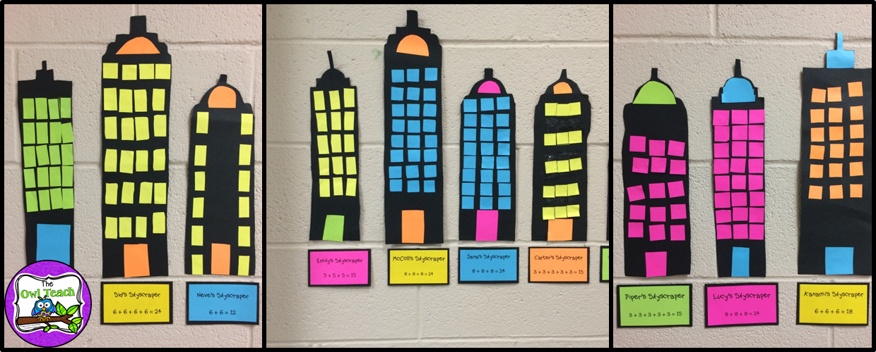  Closure: Length of Time: 15 minutes  The students will be asked to share their creations with the class, the teacher will project their picture on the white board so it is easy for everyone to see while the student explains their array building.  After everyone has shared, ask the students what successes and frustrations they had. They can write about this in their math journals. It is important to remind the students to remember the importance of problem solving. failure is an opportunity to learn. Ask students to think about what they need to be successful in this project.  Students are welcome to participate in the class discussion but will not be forced if they are uncomfortable with sharing. Remind the students that the classroom is a safe space and every opinion matters and there will be no judgment. They will share their observations/compliment/comments on the work of their peers.  The teacher will then display the students work on the bulletin board they have designated to their learning. So that every student and teacher can see what an amazing job the students did. | Materials/Resources:  https://www.youtube.com/watch?v=CtdcTDcbuW0  manipulatives  paper  scissors  glue  Management/Engagement Strategies:  - sit and listen  - hands on  - teacher scaffolding (asking questions to students while they work)  - flexible seating when working on project  - full class and small group discussions  Safety Considerations  using scissors

