Invitation for Learning Assignment
Group Component

Name: Hannah Magnusson
Grade Level: Kindergarten

Main Topic
Students will be able to understand different shapes, textures, colors and pick out different patterns

Main Curricular Outcome
CPK.4 Create art works that express own observation and ideas about the world
- Identify different lines, colors, textures, shapes, forms and patterns in surroundings and art works, and apply this understanding in own work
- Use diverse sources such as stories, poems, observation, visual images, music, sounds, or objects as inspiration for art making
- Discuss choices made in creating art works

Additional Curricular Connections
CPK.4 Create art works that express own observation and ideas about the world
- Discuss how artists and scientists use their senses to observe and record characteristics of plants, animals and humans in the envrionment (e.g., observing nature, sounds, movement and visual details)
SSK.2 Sort 3-D objects using a single attribute
- Sort a set of familiar 3-D objects using a single attribute, such as size or shape and explain the sorting rule
- Determine the difference between two pre-sorted sets by identifying the sorting rule used to sort each of them
MOK.1 Investigate observable characteristics of familiar objects and materials in their envrionment
- Identify observable characteristics of materials, such as color, texture, and odor and observable characteristics of objects, such as shape, size and weight
- Identify and explore ways to use appropriate tools (e.g., balance, funnel, stapler, hammer, glue, scissors, and containers) safely to help carry out a variety of useful tasks such as stapling, measuring, hammering, gluing and cooking
PEK.5 Vary, with guidance, the movement of the body through changes in:
- Space (personal space, genera space, levels, directions, and pathways
- Effort (time and speed)
- Relationships (body parts and shapes
- Create and perform movements, in sequence of at least two phrases, to represent images (e.g., riding a horse quickly, slowly; climbing a fence then balancing on a plank over some water; walking like a robot then stretching the body high to the sky while moving forward).
- Move over, under, around, behind, in front of, on, and off a variety of objects

Print Resources
- Mixed: A Colorful Story
By: Arree Chung
July 3rd, 2018
- We’re Different, We’re the Same
By: Bobbl Kates
October 13th, 1992
- Plant the Tiny Seed
By: Christle Matheson
January 24th, 2017
- What We Wear: Dressing up Around the World
By: Maya Ajmera, Ellse Hofer Derstine, Cynthia Pon
February 1st, 2012

Web-based Resources
- abcmouse.com: Early Learning Academy
Full online Curriculum for children ages 2-8
Includes: Reading, Math, Science, Art & Colors
The step-by step learning path presents the full curriculum in a carefully designed program of more than 850 lessons in ten levels. As children complete each lesson, they are guided to the next one and are motivates to continue learning by tickets and rewards system. There are many resources for teachers to print off as well and for children to work on activities at home with their guardians

Local Resource
- Saskatchewan Science Centre
Contact Information
- General Inquiries: (306)791-7900
- Front Desk: (306)791-7914
- Atom + Geek: (306)791-7916
- Box Office: (306)522-IMAX
- Mailing Address:
Saskatchewan Science Centre
2903 Powerhouse Dr.
Regina, Saskatchewan
S4N 0A1

References
https://www.edonline.sk.ca/webapps/moe-curriculum-BBLEARN/
https://www.abcmouse.com/
https://www.chapters.indigo.ca/
https://www.sasksciencecentre.com/

Invitation for Learning Assignment
Invitation Component

Description of the Invitation
- As the educator I will be observing the student’s ability to sort items and acknowledge certain characteristics with objects.
- For the students, they will be engaging in sorting items with specific characteristics and develop an art piece out of their designated characteristic. And then share with the class the reasoning behind what they created.
- After the students sort the objects according to characteristics (texture, size, shape, colors) they will take a piece of construction paper and create an art piece out of the certain objects they collected.
- The invitation is engaging for children that may have sensory matters
- It also allows students to engage in social communication with other students as well, other students can help sort items with students if they are having troubles
- This activity will allow hands on learners to experience sorting by using senses like touch and feel
- Kindergarten is the age that I would conduct this invitation in because it will allow them to start to engage in picking out different characteristics of objects and eventually be able to take this observing tool and apply it to everyday play
- This activity supports multiple ways of knowing because it allows for students to partake in an activity that is hands on and work on their social skills along with other subjects like, math, science, art and even can incorporate physical education
Materials Required
- muffin tins (as sorting trays)
- 1 for sorting by colors
- 1 for sorting by texture
- 1 for sorting by shape
- 1 for sorting by size
- buttons
- blocks
- seashells
- construction paper
- water beads
- bucket
- glue sticks
Space Considerations
In my classroom I would put this activity on a table where multiple students are able to participate at a time and help each other out. I would also put it close to a sink so that they could wash hands easier and, in a space, where I don’t care if they get a little messy.

Photo of Invitation

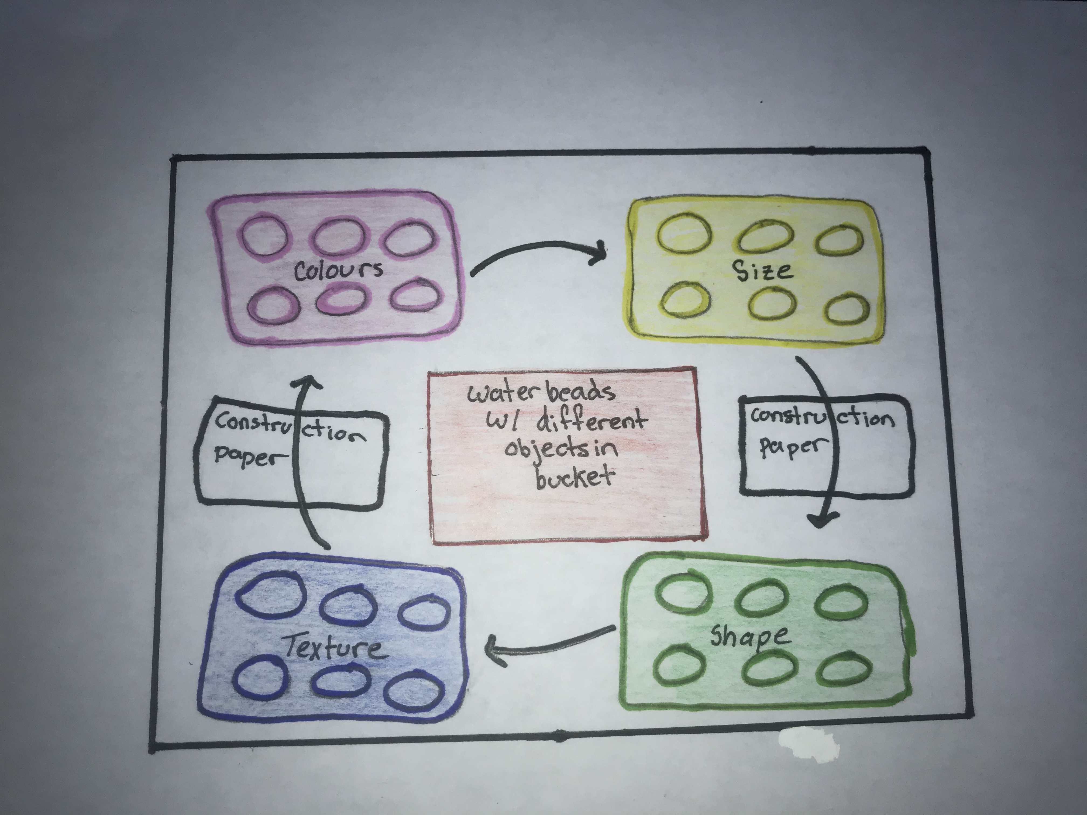

Connections to the Anti-Bias Text and Course Readings
- This certain experience supports the chapter on different abilities and fairness. It will support the needs of every child in the classroom and if that means changing things around in a different way for some students then those steps will be taken.
- An important aspect in the textbook points out that “regularly assess how well you are meeting all children’s needs” (pg. 129). I think this is very important to watch as lots of young learners can be sensitive to certain things in a classroom and making sure that I as a teacher notice these change in behaviors is important for this activity, so it can be done right and with no disturbances or out breaks
- Having the children engage in an inclusive activity will allow them to understand that even with differences we are all able to partake in the same activity, it may just be in different ways. The textbook makes a great point “support all children’s sharing of thoughts and feelings” (pg. 129). It is important to make the classroom feel like an open place where the children should be able to voice their opinions and share them with classmates and with teachers. This activity allows for that social engagement with others because they can work together to help each other sort objects and create their own artworks as a team.
References

Derman-Sparks, Louise and Olsen Julie Edwards . Anti-Bias Education for Young Children and Ourselves . Washington : National Association for the Education of Young Children , 2010.

