Grade 2 Social Studies – Interaction and Interdependence of Nations
I can…
IN2.2 Determine characteristics of a community
- I can tell the different parts that make up a school
- I can make a list of groups that students belong to
- I can identify similarities in meeting needs and achieving a common purpose
- I can describe the meaning of interdependence
- I can make a list of ways individuals contribute to a school community’s wellbeing
- I can identify characteristics common to local schools
- I can represent interdependence in the local community
IN2.2 Create a representation of the diversity of cultural groups in the local community

Lesson Number | Theme
1 | Introduce this unit by having students brainstorm who leads the school. Encourage them to think beyond the role of the principal.  - Make a web of “Our school community” and include all of the different lead roles in your school. Examples include principal, classroom teacher, art teacher, gym teacher, health teacher, caretaker, librarian, secretary, etc. (students can fill their own copy of the school community web using “Groups I Belong to”
2 | Comparing school & family  - Schools and families are two main communities that students recognize themselves being a part of  - Read the story “the family book” by Todd Parr  - Have students consider how being a part of a school community can be similar and different to their family  - Have each student fill in the worksheet “comparing communities: a Venn Diagram
3 | Read “bread comes to life” by George Levenson (on YouTube). Discuss with students how they get the bread that they eat in their homes. Ask students to consider how different services in their community contribute to meeting out need and wants  - What does a baker provide?  - What do hospitals provide?  Have students complete some/all of the pages in the roles in my community” booklet
4 | How do you contribute to the community?  - Have the students consider how they can contribute to their school’s wellbeing. What are ways they can help make other’s jobs easier in your school
5 | Treaty Education  - Treaty making  - What is a promise?  - Classroom promises  - Making an agreement
6 | Treaty education  - What is a treaty?
7 | Interdependence within the community  - There are many ways that communities work together to meet the needs and wants of the people. When community groups work together, they are demonstrating interdependence  - Have students think of ways that different groups rely on each other to survive (ex, bakers rely on farmers to produce and harvest wheat. This wheat is needed to make flour, which is then used to bake cakes. Selling these cakes keeps bakeries in business)  - Cut and paste
8 | All About me Glyph  - Discuss with the students how we are all different. We have different hair colour, eye colour, height, styles, etc. Explain how these differences keep us interesting. If we were all the same, we would be really boring  - Read “it’s okay to be different” by Todd Parr
9 | Cultural traditions, festivals & Celebrations  - http://Saskatchewanderer.ca  - Have them create their own blog post. Draw a picture of a time they explored Saskatchewan and write 3 things, what they saw, what they learned, and one good thing.

Subject/Grade: Social Studies 2 Lesson Title: Roles in my School Teacher: Miss Magnusson
Stage 1: Identify Desired Results
Established Goals: (Learning Outcomes)
IN2.2 Determine characteristics of a community

Identify and record characteristics common to the school community (e.g., who leads the school community? Who keeps the school community clean and physically pleasant? What kinds of special events happen in the school community?)

KUDs  Know: Students will know…  - Students will know what a community is  - Students will know the roles in their school  - Students will know what jobs that align with certain roles | Essential Question(s):  What is a community?  What communities are you a part of?  What roles are shown in our school community?  What jobs are a part of the roles in our school?
Understand: Students will understand (can be written as I Can statements)

- I can describe what communities I am apart of
- I can name leaders within my school community
- I can name jobs for their roles

Do: Students will be able to

- Students will be able to demonstrate roles in the school community
- Students will be able to choose communities they are a part of
- Students will be able to pick out jobs of a role

Instructional Strategies: (list such as graphic organizers, manipulatives, games, storytelling, etc)

Game in the development – charades of the roles in the school community
Worksheet – allowing them to write down what communities they belong to

Stage 2: Determine Evidence by Assessing Learning
Looking at whether or not they completed the worksheet

Stage 3: Build Learning Plan
Set (Engagement/hook) Length of Time: 10  This video provides on overview of what a community is and how we belong to so many different communities: https://www.youtube.com/watch?v=lGC0zxgRNJQ  What were some of the communities that they mentioned in the video?  Do you belong to any of these communities?  Making a web we are going to brainstorm some communities we might belong too.  - Ex. School, dance, hockey, neighbourhood, church, family, classroom  Encourage students to participate in the discussion and to name communities they are a part of. Raising their hand to participate in the discussion and waiting for their name to be called.  Development: Length of Time: 20  Let’s begin to focus on our school communities and some of the roles that are found within the community.  During this time, we will have a discussion on what roles are in the school and I will write them up on chart paper  Asking the students to raise their hands when they have an answer.  Who do you see working in your school?  Examples are:  - Principal: run the school  - Librarian: read books  - Classroom teacher: be organized  - Gym teacher: be active/moving  - Caretaker: be helpful  - Students: listen and learn  After we have completed this part of the discussion, we will move on to listing some jobs of what they do during the day.  Now let’s look at some roles these people do in the school. For example, principals are leaders in my school. The Principals job is to run the school.  Can you come up with any other roles these people we have listed have in the school and what their job is to do every day?  Some examples are listed above of some potential roles of their jobs.  When we are finished discussing the jobs that the people do in the school. We will start the game or charades.  I will have paper with the names of roles on them in a bowl for the students to choose from.  They will each get a turn to act out a role and the other students will have to raise their hand and be called on to guess what role they are acting out  Everyone will get a turn to participate in the activity whether that be acting the role/job our or guess what your friends are doing. While we are watching our friends act out the roles, we need to remember to stay quiet and when you think you know the answer to raise your hand and wait to be called on.  When everyone has finished getting a turn in some way or another. They will be asked to sit and wait for the worksheet to be passed out.  Closure: Length of Time: 20  The students will then get a worksheet called “I belong to”. With this sheet they will list 3 roles they find in their school and then write what their job is to do during the day.  Now let’s look at writing down some of the jobs we can find in our school community. Together we will complete the first one and the second and third on you will complete on your own. You may use the webs we have created and the list to help guide you.  In the first blank let’s write down principal. Now what is the principals job during the day?  See if any of the students can answer the question before giving them an answer.  The Principals job is to run the school. Let’s fill in the blanks on your worksheet. Now work on your own to fill in the rest of the blanks on your worksheet.  When you are completed your worksheet, you will hand it in to me. After you have handed it into me you may either grab your playdough, book bag or Lego bags and work quietly at your desk while others finish.  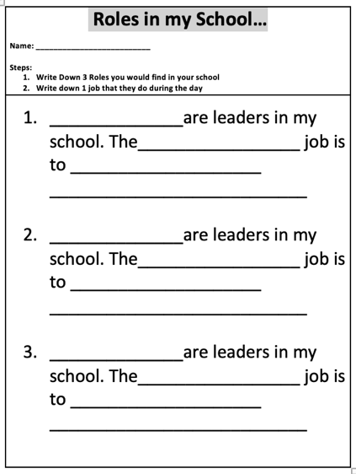 | Materials/Resources:  - Projector  - YouTube video (https://www.youtube.com/watch?v=lGC0zxgRNJQ)  - Bowl/hat  - Roles on paper to play Charades  - Worksheet for the students  Management/Engagement Strategies:  - Using hocus pocus when the students are getting loud during a discussion  - Having the students participate as much as possible  Safety Considerations  - Making sure everyone is getting a turn  - Adequate space

Subject/Grade: Social Studies 2 Lesson Title: Comparing School & Family Teacher: Miss Magnusson
Stage 1: Identify Desired Results
Established Goals: (Learning Outcomes)

IN2.2 Determine characteristics of a community

Compare characteristics of other communities to which students belong with those of the school community, identifying the similarities in meeting needs and achieving common purpose

KUDs  Know: Students will know…  - Students will know how to compare family and school communities  - Students will know the difference in family and school community  - Students will know how to find similarities in the communities | Essential Question(s):  What are differences between our school community and our home communities?  What are similarities between the two?
Understand: Students will understand (can be written as I Can statements)

- I can identify the difference between family and school
- I can compare two different communities
- I can find similarities in the two communities

Do: Students will be able to

- Students will be able to separate differences using a diagram
- Students will be able compare two communities
- Students will be able find similarities between school and home

Instructional Strategies: (list such as graphic organizers, manipulatives, games, storytelling, etc)

- Graphic organizer: Venn Diagram or T-Chart

Stage 2: Determine Evidence by Assessing Learning
Taking the worksheet in at the end to see if they have completed it fully and were doing the right task at hand.

Stage 3: Build Learning Plan
Set (Engagement/hook) Length of Time: 10-15 minutes  Let’s review what we learnt last class. Who can we find in our school community? What leaders do we see and their jobs?  Let the students answer and list some of the leaders in the school that we talked about last class.  Explain to them that we are all a part of our school community and our own family community.  We are all a part of these communities but all in different ways. I am a part of this school community when I come in and teach, but I am also a part of my own family community by being a granddaughter, daughter and a sister. We are going to read a book about family’s and how they can look different for everyone.  I want you to look for 3 different families while we listen to the book. Try to remember what they are and what they may look like.  The family book - https://www.youtube.com/watch?v=AyVL9bH0guk  Some families are big some small  Some families are same colours, and some are different colours  Some live near and some live far  Some families look alike, some families look like their pets  Some families have stepmoms, stepdads, stepsisters, stepbrothers  Some families adapt children  Some families have two moms or two dads  Some families have one parent instead of two  Some families eat the same things some eat different things  Some families like to be clean; some like to be messy  All families can help each other be strong  What were some things you saw in the book about families?  Development: Length of Time: 20  We are going to look at the differences of roles in our school community and our family community. And also, some of the similarities (things we find in both) communities.  Can anyone tell me who they see in the school but do not see in their family community? Who do you see in your family?  Let’s list 5 people in our school community and 3 things we do at school.  Now let’s move to family, again let’s list 5 leaders/people we find in our families and 3 things we do at home with our families.  Compile a list of people we see in our school and who we see in our family community. This can be done by making a T-Chart on chart paper.  Who might we see in both of these communities? For example, you might go to school with your siblings. Do any of you go to school with family members?  What do you do differently in your home community, then here at school? What’s something you do at school but not at home? Is there anything you do the same of at home and school, like maybe reading books, eating lunch…does anyone want to share?  During this time, we will be discussing these questions one at a time, so that it does not overwhelm the students with having to answer multiple questions.  Closure: Length of Time: 10-15 minutes  Once we have completed our discussion, we will look at filling in a Venn Diagram of what we talked about in today’s lesson. I will give them an example in each to get them started off.  We are going to be filling in a Venn Diagram and working on our own. In the first circle we are going to write down someone we find or something we do at school, for example a teacher. Can you all write that down in your first circle.  Now let’s move onto the second circle, our family community. An example of someone or something in our family community might be eating lunches. Let’s write that one down in that circle.  Moving to the middle circle on the worksheet we are going to look at what we can find in both family and school communities. For example, can we eat lunch at school? Can we eat it at home with our family? If yes let’s right that example down in the last column.  Now work on you own to complete the rest of the work sheet, list at least 3 more in each column.  When you are completed your worksheet, you will hand it in to me. After you have handed it into me you may either grab your playdough, book bag or Lego bags and work quietly at your desk while others finish.  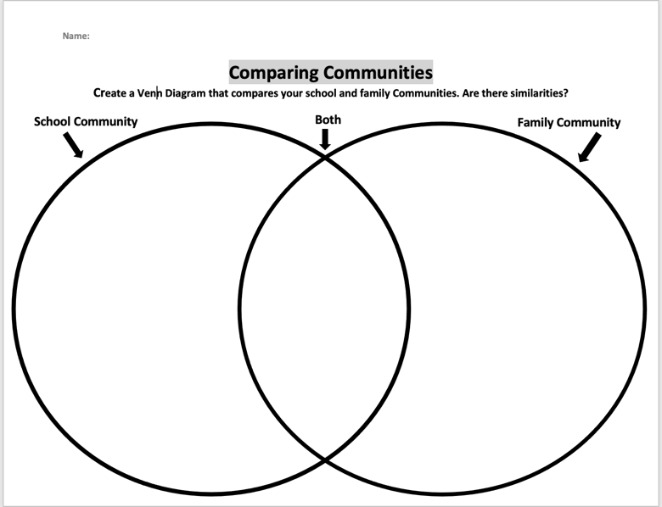 | Materials/Resources:  - Family book  - Chart paper  - Worksheet  Management/Engagement Strategies:  - Engaging all the students in discussion  - Hocus pocus to make sure they are staying focused  - Meaningful discussion  Safety Considerations

Subject/Grade: Social Studies 2 Lesson Title: Roles in my Community Teacher: Miss Magnusson
Stage 1: Identify Desired Results
Established Goals: (Learning Outcomes)

IN2.1 Determine characteristics of a community

(d) Identify needs met by the local community that cannot be met independently or individually, and describe the concept of interdependence

(e) Create and inventory of ways in which individuals and groups contribute to the well-being of the school and local community

IN2.2 Create a representation of the diversity of cultural groups in the local community

(d) Describe ways in which diverse individuals and groups contribute to the well-being of the local community (e.g., storekeepers, medical practitioners, law enforcement personnel, support workers, spiritual of faith leaders, artisans, trades people, bus drivers, community maintenance workers.

KUDs  Know: Students will know…  - Students will know what community members help others well-being  - Students will know how to describe ways in which diverse individuals and groups contribute to the well-being of the local community | Essential Question(s):  Who do we find in our community?  What services do we fin din our community?  What are some jobs that come with these services?  How do these jobs help us in the community?
Understand: Students will understand (can be written as I Can statements)

- I can describe individuals who contribute to the well-being of the community
- I can see local community members who help in the community
- I can connect how different services in the community contribute to the meeting our needs and wants

Do: Students will be able to

- Students will be able to describe different community members jobs
- Students will be able to connect different jobs to the well-being of others in the community

Instructional Strategies: (list such as graphic organizers, manipulatives, games, storytelling, etc)

- Booklet: Roles in my community.
- Using attention grabbers

Stage 2: Determine Evidence by Assessing Learning
- Looking if they followed the instructions
- Wrote a completed sentence
- Gave two jobs that could be found in the service

Stage 3: Build Learning Plan
Set (Engagement/hook) Length of Time: 10-15 minutes  Review what we learnt in the last lesson.  We are going to begin to look at our city community and some of the leaders or buildings we may find in it. For example, we see nurses, firefighters, store workers and many more. Can you name any?  Where might these people work?  Nurse works in a hospital.  Fire fighter works in a fire station.  Development: Length of Time: 30-40 minutes  Ask students to consider how different services in their community contribute to meeting our needs and wants.  What do hospitals provide us with?  What does a bakery provide us with?  What do grocery stores provide us with?  What do movie theaters provide us with?  What does the gas station provide us with?  Within these services there are many jobs that can be found in them. For example, at the movie theater we can find people who work at the food counter or sell tickets. Can you think of any more jobs we might find in the movie theater?  All these services like the movie theater provide people with _____ (jobs). Do you have a movie theater in your community?  Let’s try another one. What jobs can we find inside a hospital?  Give them time to think about it.  We can find many different jobs like, nurses, doctors, caretakers, office managers. All these jobs of specific roles that they do through out the day.  Let’s talk about why these communities need these services.  The community needs a hospital because they help the sick. Our community needs a school because students need to learn.  Can you think of any other services in the community are important to have?  Closure: Length of Time: 10-15 minutes  Working on the “roles in my community book”. They will circle yes or no if they can find the services in their community. Then they will list some jobs that they can find within in the services. The last step is to write why the service is important to the community.  We are going to work on a booklet about the roles in our community. You will circle yes or no if you can find this service building in your city community. Following that the second step is to write jobs you might find in these buildings. And the final step is to write why we need this building in our communities.  You will write down 2 jobs that you might find in this service place/building. And for the last section I would like 1 complete sentence with capitals and proper punctuations.  When working on the booklet, please work quietly at your own desk by yourself. If you have any questions raise your hand.  After you have completed the writing and all the steps in the book, work quietly at your desk to colour the pictures with pencil crayons.  After this you will hand it into me. Work quietly at your desk with your Lego bags.  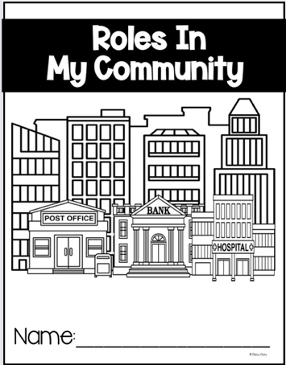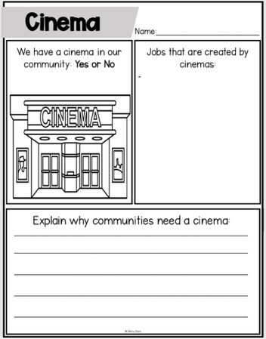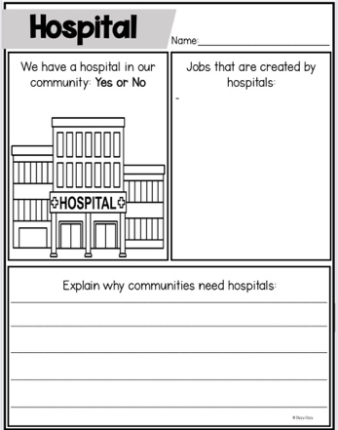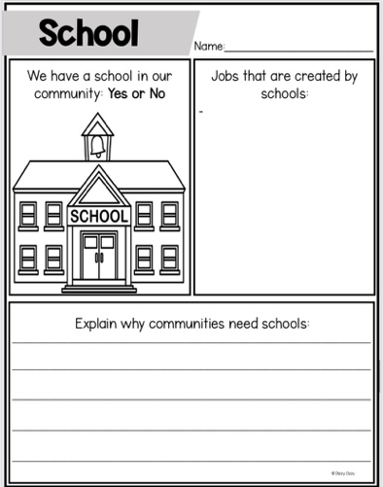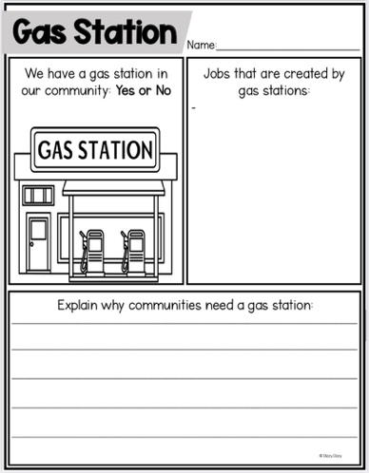 | Materials/Resources:  - White board  - Booklets  Management/Engagement Strategies:  - Attention grabbers  - Leading a discussion  - Using actions to help them stay motivated  Safety Considerations  - Safe space to move

Subject/Grade: Social Studies 2 Lesson Title: How to contribute to my community Teacher: Miss Magnusson
Stage 1: Identify Desired Results
Established Goals: (Learning Outcomes)

IN2.1 Determine Characteristics of a community

(e) Create an inventory of ways in which individuals and groups contribute to the well-being of the school and local community

Cross Curricular Components

CP2.1 Create and connect dance phrases using ideas about community as stimuli (e.g., our school, community events, farm life, city life, cultural heritage)

- Select and connect movements from explorations to create dance phrases

CP2.6 Create and perform music that demonstrates understanding of:
- form (repetition and contrast)
- beat (strong and weak beats/accents) and meter (2/4 and 4/4)
- rhythm (create ostinato)
- tempo (fast/slow paces)
- dynamics (loud/soft)
- pitch (high/low sounds) and pitch direction (moving up/down/staying the same)
- texture (layers of sounds)
- tone colour (variety).
(d) | Maintain a steady beat (pulse) and identify accents with a strong movement.

KUDs  Know: Students will know…  - Students will know how they can help their community  - Students will know how to keep a beat  - Students will know how to do actions with words | Essential Question(s):  What are ways you can help your community/  What are some ways you already help in your community?
Understand: Students will understand (can be written as I Can statements)

- I can find ways to help in my community
- I can follow directions
- I can listen to the beat
Do: Students will be able to

- Students will be able to give ideas of how they can contribute to a community
- Students will be able to follow along and give a beat
- Students will be able to put actions to words

Instructional Strategies: (list such as graphic organizers, manipulatives, games, storytelling, etc)

- Music/song to show ways we can help the community
- PowerPoint Presentation to help them list off ideas of how they can help their community

Stage 3: Build Learning Plan
Set (Engagement/hook) Length of Time: 10-15 minutes  Review what we talked about in the last couple lessons  We have talked about many different communities. We have talked about our school community, family community and our city community. And who we find in these communities and what they give us.  We are going to watch a video and I want you to try to pick out the key points while listening to the song.  https://www.youtube.com/watch?v=H98Rfljxmsc  Examples  - Kindness can bring a smile to someone’s face  - It doesn’t take much  - It doesn’t cost a thing  - You can do it anytime  - Give it out to anyone  - You can put it into words  - You can share it with you neighbour or friends  - The worlds a better place when we have kindness  Development: Length of Time: 30-40 minutes  Now that we have listened to a song about what kindness can do to the world and our communities, we are going to look at some ideas of how we can bring kindness to our communities  We can also see these tasks as helping others and random acts of kindness and ways that you can help in your community.  Can anyone tell me what they might do for their community? How do you help out in your community? What can you do to help out in your community?  Things we do in our community to help  - Picking up garbage  - Walking a pet  - Making someone smile  - Donate clothes/books  - Buying local  - Sharing  Let’s look at this picture of me on the board. Can you help me decide what I can do in my community to help spread kindness?  Have the students raise their hands when they are ready to share their answers.  Learning a song https://www.youtube.com/watch?v=H0Kg8yyaS_g  Step 1: Teach them how to give a beat  This will be done with the beginning and the end lyrics  - Clap  - Stomp  - Clap  - Stomp  Step 2: Teach them the words  You are going to repeat after me. When I point to you that is when you say it back to me.  Step 3: Teach them the actions  Repeat the words but give them actions to the ending words, like:  - Kindness  - Donate books  - Recycle paper  - Help parents  - Make someone smile  - Give a hug  - Plant a tree  - Donate clothes  Step 4: Put it all together.  We are going to do the song and actions together now. I want you to watch me while we do the song to follow along. There will be no silly business happening.  Everyone needs to be standing at their own desk. You may either follow along on the board or the piece of paper in front of you  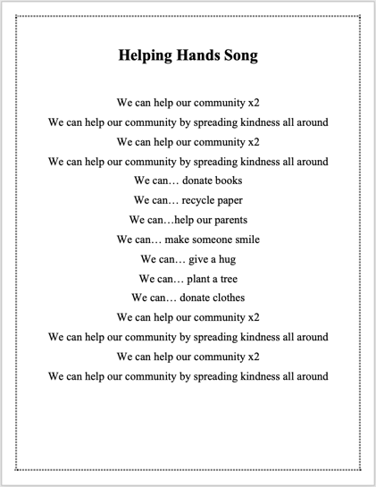  Closure: Length of Time: 10-15 minutes  I want you to draw a picture of something that was mentioned in the song that we can do that spreads kindness.  Start off by putting your name on the back of the page. The next step is to look at the board and pick one of the acts to spread kindness.  Now you are going to draw a picture of this act and how you think it would look in a community.  When you are done drawing your picture you can hand it into me when you are finished. Then you may work by yourself quietly at your desk with your Lego bags. | Materials/Resources:  - Projector  - YouTube  - Worksheet/paper  Management/Engagement Strategies:  - Using attention grabbers when they are getting out of control maybe during the song  - Using a song to help them learn  Safety Considerations  - Adequate space  - Volume of music  - Noise volume of the kids in the class. Not getting too loud.

Subject/Grade: Social Studies 2 Lesson Title: What makes a Treaty Teacher: Miss Magnusson
Stage 1: Identify Desired Results
Established Goals: (Learning Outcomes)

IN2.2 Create a representation of the diversity of cultural groups in the local community

- Describe diverse characteristics within the school and local communities and describe similarities within and between diverse groups

Treaty Education Outcomes

HC2.3 Analyze the traditional forms of leadership that were in practice prior to European contact and in First Nations communities
- Describe the concept of consensus from student’s own experience (e.g., deciding what restaurant to go to, what game to plat at recess).

TR2.1: Examine how the Treaties are the basis for harmonious relationships in which land and resources are shared.
- Examine the concepts of peace and harmony and provide examples of how these concepts are expressed in people’s lives and discuss why these concepts are important.
- Discuss the First Nations concepts of sharing (e.g., traditional community ownership vs. individual ownership) and consider what sharing the land and its resources might mean.

KUDs  Know: Students will know…  - Students will know how to look for key concepts in a book  - Students will know how to understand treaty issues  - Students will know how to see diverse characteristics in a community | Essential Question(s):  What are some ways we can include everyone?  Do we see different cultures in our school community?
Understand: Students will understand (can be written as I Can statements)

- I can describe characteristics within local communities
- I can fill in a worksheet with the class
- I can understand why there were troubles when making treaties

Do: Students will be able to

- Students will be able to answer questions guided by a book
- Students will be able to see diversity in a community
- Students will be able to understand what made a treaty difficult to negotiate

Instructional Strategies: (list such as graphic organizers, manipulatives, games, storytelling, etc)

- Guided reading – Understanding Each Other
- Worksheet – help give them tasks to look for whole reading

Stage 3: Build Learning Plan
Set (Engagement/hook) Length of Time: 10-15 minutes  Asking them if they know what a treaty is. Who lives in a treaty?  Does anybody know what a treaty is and who lives on a treaty?  A treaty is an agreement between two or more people or the government. A treaty is what we live on.  Development: Length of Time: 30-40 minutes  We are going to read a book called Understanding Each Other.  Does anyone want to guess what the book might be about?  Let them have three guesses before I start reading the book  When I am reading the book, I want you pay attention to the words of the book and look at the pictures.  After a couple pages I will stop and read a question. We will work together to complete the questions one at a time.  While I read the book, I will walk around the front of the room to show them the pictures and also make sure that I pronounce new words with confidence.  I may also stop to ask the students if they know what the word means, like what a reserve is.  What is a reserve? Reserves divided up lands  After we are done the worksheet together, they will put it in their duo tangs so that they can have them to refer back to in the future.  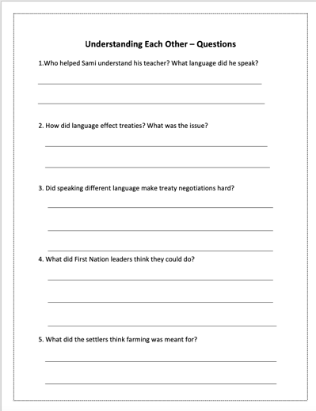  Closure: Length of Time: 10-15 minutes  When we read the book. What did you notice about the school community? That there were many different cultures. In our community we want to include everyone.  When we looked at spreading kindness the other day, what do you think are some ways that we can help everyone feeling included in our school community?  Examples:  - Playing with them at recess  - Helping them if they don’t understand something | Materials/Resources:  - White board  - Projector  - Worksheet  Management/Engagement Strategies:  - Slow reading  - Looking at the pictures  - Asking questions  Safety Considerations

Subject/Grade: Social Studies 2 Lesson Title: What is a treaty? Teacher: Miss Magnusson
Stage 1: Identify Desired Results
Established Goals: (Learning Outcomes)

IN2.2 Create a representation of the diversity of cultural groups in the local community
- Describe diverse characteristics within the school and local communities, and describe similarities within and between diverse groups

DR2.4 Describe the influence of Treaty and First Nations people on the local community
Identify on a map the treaty territory within which the local community is situated

Treaty Education Outcomes

TR2.1: Examine how the Treaties are the basis for harmonious relationships in which land and resources are shared.
- Examine the concepts of peace and harmony and provide examples of how these concepts are expressed in people’s lives and discuss why these concepts are important.
- Discuss the First Nations concepts of sharing (e.g., traditional community ownership vs. individual ownership) and consider what sharing the land and its

KUDs  Know: Students will know…  - Students will know what a treaty is  - Students will know where all the treaties are in Saskatchewan  - Students will know what happens in a treaty | Essential Question(s):  What treaty do we live on?  What is a treaty?  How have treaties helped Canada?
Understand: Students will understand (can be written as I Can statements)

- I can identify what treaty I live on
- I can label a map of Saskatchewan’s treaties
- I can pick our characteristics in a treaty

Do: Students will be able to

- Students will be able to identify their treaty
- Students will be able to colour match the treaties
- Students will be able to explain what a treaty is

Instructional Strategies: (list such as graphic organizers, manipulatives, games, storytelling, etc.)

- Worksheet: colour matching, labeling treaties
- Storytelling: We are all treaty people

Stage 3: Build Learning Plan
Set (Engagement/hook) Length of Time: 10-15 minutes  Review what was talked about in the last lesson.  Were treaty negotiations hard to build? Why was this?  Today we are going to look deeper into what a treaty is and how they have affected our communities.  We are going to read the book “We are all treaty people”. What do you think this book will be about?  Development: Length of Time: 30-40 minutes  You have a couple jobs to do while I am reading this story to you.  - I want you to listen for the word treaty/treaties and try to remember what they mentioned  - Look for words that stand out to you and that you think are important to remember  - I want you to listen for how treaties helped our country/province  Begin to read the book. When you come across a new word or definition stop and reread it so that they students can hear it twice and remember the important facts.  After we have completed the book, we will have a discussion on what makes a treaty and what a treaty is. I will write this one chart paper so we can come back to this idea of we are all treaty people.  If the students don’t know the answer to the question, go back in the book a reread the page.  Who can tell me what a treaty is?  - Treaties are the agreements we made so we could all live together  - Treaties are like a promise between two or more people  How have treaties helped build Canada?  - First Nations made treaties so that newcomers could build on the land  - Treaties helped build hospitals, roads  What is a reserve?  - Land set aside for First Nations people  Are treaties meant for everyone?  - Thumps up for yes, thumbs down for no  Now that we know what a treaty is and a little more about First Nations peoples. Let’s focus in on our province.  Can anyone tell me what province we live on?  Right Saskatchewan. Can anyone guess how many treaties are in the province?  Give them three guesses before telling them the right answer  The right answer is six. Saskatchewan has many different treaty communities that we share the land with and live on together.  I am going to model for you a land acknowledgement that we do to acknowledge the First Nations communities that live on our treaty.  Does anyone know what treaty Regina is on?  That’s right we live on treaty 4 territory  Listen carefully to all the communities of First Nations I mention in the and acknowledgment.  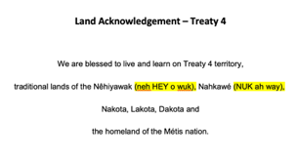  Closure: Length of Time: 10-15 minutes  Now that we have a better understanding of what a treaty is, let’s label a map of all the treaties we find in the province.  Have the students repeat back what the steps are so that they know what they are required to do and so that you know they know what is required of them.  The first step is to put your name on the page.  The second step is to listen carefully for what I ask to colour with. We will be using pencil crayons to colour in the map.  There is a list of all the treaties in Saskatchewan at the bottom of the page. Looking at these I want you to match the colour to the treaty.  Go through the colours with them before starting and where to look.  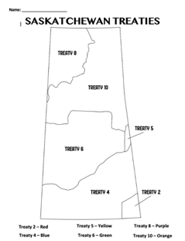 | Materials/Resources:  - Chart paper  - We are all treaty people book  Management/Engagement Strategies:  - Storytelling  - Hocus pocus  - Colouring  Safety Considerations
Subject/Grade: Social Studies 2 Lesson Title: Giving to my community Teacher: Miss Magnusson
Stage 1: Identify Desired Results
Established Goals: (Learning Outcomes)

IN2.2 Create a representation of the diversity of cultural groups in the local community

(d) Describe ways in which diverse individuals and groups contribute to the well-being of the local community (e.g., storekeepers, medical practitioners, law enforcement personnel, school support workers, spiritual or faith leaders, artisans, trades people, bus drivers, community maintenance workers).

KUDs  Know: Students will know…  - Students will know how community workers help other community workers  - Students will know how certain groups contribute to the local community | Essential Question(s):  What community helpers rely on each other?  Do you see community helpers working together in your community?
Understand: Students will understand (can be written as I Can statements)

- I can see which community helpers work together
- I can understand how they work together

Do: Students will be able to

- Students will be able to link helpers to other helpers in the community
- Students will be able to sort their ideas through the cut and paste

Instructional Strategies: (list such as graphic organizers, manipulatives, games, storytelling, etc)

- Cut and paste: students would engage in a worksheet that will be completed at the end of the lesson to see if they understood what was taught that day.

Stage 3: Build Learning Plan
Set (Engagement/hook) Length of Time: 10-15 minutes  Let’s look back on what we have learnt about community already. We know that we can find leaders in our communities. Who might we find in our school community?  Now can you think of any community helpers that really help each other?  We are going to watch a video on careers, I want you to look at what jobs help other jobs in a community.  https://www.youtube.com/watch?v=soKRa6D90WQ  During the video I want you to focus on all the different jobs that you see. How might some of these jobs help each other in their communities?  This is showing interdependence, when we rely on others to help get a job done.  Development: Length of Time: 30-40 minutes  There are many ways that communities work together to meet the needs and wants of the people. When community groups work together, they are demonstrating interdependence.  Interdependence can be described as people working together to make one big thing happen. The joining of two or more groups to make one large group.  In an emergency we might see many groups show up like the police, ambulance and fire fighters.  Do we know any communities that help out a larger community? For example, a grocery store. Where do you think all the bread comes from? That’s right a bakery. So, bakeries are a community that helps out the grocery store to help them serve their customers.  Making a web on the board for the different communities we have looked at. This will allow them to see with one big community there are a bunch of different communities that help them achieve their goals.  In our past lesson we talked about treaties. Can anyone name a community that helped build treaties? For example, in the book we read it said that First Nations helped build our communities and also, settlers.  We could go on about how different communities helped other communities become better.  Does this remind you of the song we did the other day? The communities are working together to spread kindness to other communities.  I think this is a good time we review our song.  This is where I will pause and review the beat with them and the lyrics and actions together. Then we will do it with the music. This will be like a movement break for the listening they have been doing.  Let’s review the beat of the song and the lyrics and actions together. Good job, now time to put it all together with the music.  Closure: Length of Time: 10-15 minutes  Now that we know that so many different people can contribute to the well-being of many communities. We are going to organize them into their locations.  We are going to do a cut a paste. With this at the top it will have the big community. Then on another piece of paper are a bunch of different communities that could help build the big one up.  The first step is to put your name on the back of the sheet with the empty boxes.  The second step is to start to cut out the boxes that have words in them. These pieces are going to be glues under the section you think belongs to.  Let’s do the first one together. Farmers, where do you think farmers would be long. What community needs help from farmers?  That’s right under the grocery store, because they help provide all the veggies and fruit for us to eat.  Now try on your own to organize the rest of them into where you think they belong.  When you are done this, you may colour in your squares if you like with pencil crayons.  And once you are done that you may have free time on your own with you playdough or Lego bags.  Construction  - Builders  - Carpenters  - Architects  - Electricians  - Plumbers  Emergency  - Police officers  - Ambulance  - Doctors  - Fire fighters  Grocery Store  - Bakery’s  - Farmers  - Dairy Farmers  Schools  - Teachers  - Principals  - Caretakers  - Students  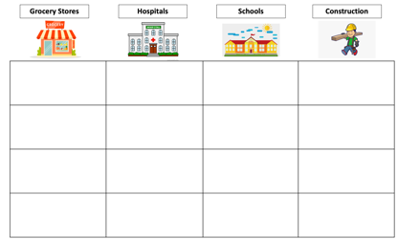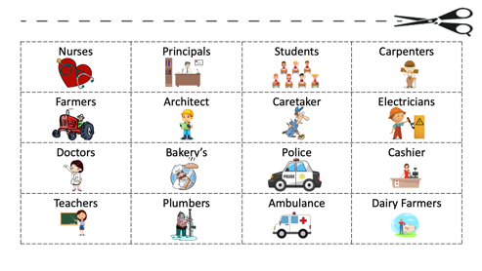 | Materials/Resources:  - Chart paper  - White board  - Worksheet  Management/Engagement Strategies:  - Repeat back to me for instructions  - Hocus pocus (attention grabber)  - Engaging in a discussion  - On task when doing a worksheet  - Cooperating when doing the song together  Safety Considerations  - Adequate space for the song  - Making sure everyone gets a chance to participate in the discussion.

Subject/Grade: Social Studies 2 Lesson Title: Diversity Teacher: Miss Magnusson
Stage 1: Identify Desired Results
Established Goals: (Learning Outcomes)

IN2.2 Create a representation of the diversity of cultural groups in the local community

- Describe diverse characteristics within the school and local communities and describe similarities within and between diverse groups

Cross Curricular Components

CP2.7 Create art works that draw on observations and express ideas about own communities

KUDs  Know: Students will know…  - Students will know what diversity is  - Students will know what makes them different from others  - Students will understand that all communities are diverse | Essential Question(s):  What is diversity?  How are we all different?
Understand: Students will understand (can be written as I Can statements)

- I can explain what diversity is
- I can see what makes me different

Do: Students will be able to

- Students will be able to define diversity
- Students will be able to see what makes them different
- Students will be able to see that every community is different

Instructional Strategies: (list such as graphic organizers, manipulatives, games, storytelling, etc)

Music – To show them about diversity
Video – To further explain diversity
Art – Allowing them to explore their differences

Stage 2: Determine Evidence by Assessing Learning
- Assessing if they completed it and if they followed the instructions and did everything that was asked of them
  - Did they have 3 differences
  - Did it fill the page?
  - Was it coloured?

Stage 3: Build Learning Plan
Set (Engagement/hook) Length of Time: 10-15 minutes  What have we been talking about these last couple weeks? Communities.  Now we are going listen to this song while watching I want you to listen to what the song is about and what it is teaching us.  We’re All Amazing - https://www.youtube.com/watch?v=vbHQ-OS9_G0  By raising your hand, who can tell me what the song was about?  Can anyone tell me by raising their hand what we call all these differences. I’ll give you a hang it starts with a D. DIVERSITY!  Raising your hand does anyone know what diversity means?  At this point in the lesson on chart paper I would write the word DIVERSITY. So that they can see the word.  Development: Length of Time: 30-40 minutes  We are going to watch another video that better explains what diversity is. Your job as we watch the video is to listen to what I am reading off the board.  After the video I am going to ask you again what diversity means. We will record your answers on the chart paper so that we can all see them written out. Watch and listen carefully for what diversity means.  What is diversity - https://www.youtube.com/watch?v=H27g16TnvJI  Who can tell me without blurting out answers what diversity is?  Examples  - Diversity is being different  - Different languages  - People can look different  - People can talk different ways  - People can believe different things  - People can live in different places  Going around the room you are going to tell me one thing that makes you different from others?  This could be from your eye colour, your height, a different language you speak, the colour of your hair, or as simple as if you wear glasses?  Give the students an example:  I am different because I have brown eye.  Remember I only want ONE thing that makes you different. If you don’t want to share, just say PASS  I want you to start your sentence with “I am different because…”  Have them repeat back to me what I am looking for when going around the room.  Write up on the board “I am different because…  I reminder that we are sitting quietly in our desk listening to our friends when they are speaking  Making sure everyone is on task when we are going around the room and that they are all listening to their friends talk.  Explain to them that this is what makes our school community diverse. Because there is not a single person in the school that are identical (the same)  Closure: Length of Time: 10-15 minutes  I want them to draw themselves and list 3 things around them that are special to them.  I will demonstrate this on the board with them using myself as an example.  For example:  - I speak English and learning ASL  - I have brown eyes  - I am short  - I live in Regina  - I wear glasses  Using different colour markers to demonstrate the different things about me on the white board.  Now I want you to use this blank piece of paper to draw yourself and write 3 things that are different about you.  Step 1: put your name at the top of the page  Step 2: draw yourself using the whole page  Step 3: write down 3 things that are special about you  Step 4: colour your picture, you may use whatever you would like to colour  Step 5: Hand it into the finished bin  And if you finish all of this you may play with your playdough silently at your desk.  Are there any questions before we begin?  When working I want you to be working quietly on your own at your own desk.  I will play quite music in the background if you are on task doing your job.  If you have any questions, please raise your hand and I will come to you.  I will play the music through my phone onto a Bluetooth speaker so that the students can refer back to my drawing on the board.  Relaxing Music - https://www.youtube.com/watch?v=ItWHjybdZUU | Materials/Resources:  - Chart paper  - White board  - Projector  - Video links (in lesson plan)  Management/Engagement Strategies:  - Clear instructions  - Repeat back to me and repeating what they say when answering a question  - Managing the classroom during a discussion  - Using a circle talk  Safety Considerations  - Making sure everyone is being heard

Subject/Grade: Social Studies 2 Lesson Title: Cultures and Traditions Teacher: Miss Magnusson
Stage 1: Identify Desired Results
Established Goals: (Learning Outcomes)

IN2.2 Create a representation of the diversity of cultural groups in the local community

(c)Identify the significance of a variety of cultural traditions, festivals and celebrations in the school and local communities

KUDs  Know: Students will know…  - Students will know some new cultures and celebrations in the school  - Students will know their own celebrations and traditions in their family | Essential Question(s):  What are some cultures I can find in my school?  What are some cultures and celebrations I can find in my own family community?
Understand: Students will understand (can be written as I Can statements)

- I can understand different cultures
- I can respect different cultures and traditions
- I can define my own culture in my family’s community

Do: Students will be able to

- Student will be able to respect different cultures and traditions
- Students will be able to see different cultures and traditions
- Students will be able to work on their own family traditions and celebrations

Instructional Strategies: (list such as graphic organizers, manipulatives, games, storytelling, etc)

- Worksheet to help them define their own family culture

Stage 3: Build Learning Plan
Set (Engagement/hook) Length of Time: 10-15 minutes  Cultures around the world (9 Minutes) - https://www.youtube.com/watch?v=RwSYrsjTiW4  Stopping the video at 4:50  I will then ask them questions of what they noticed in the video.  Does culture help define our communities? Does it make our communities different?  Do we see different cultures in our own communities, whether that be at school or our neighbourhood community?  Development: Length of Time: 30-40 minutes  We are going to now take a tour around the world to 4 countries.  Link to slides - https://drive.google.com/file/d/1aMCaEPg7ama9LmSuhWq2XGv6HBqUTKWv/view?usp=sharing  I will use these slides to take the students to different countries and explore the languages, foods and traditions of their culture.  The first stop is the Philippine. Does anyone know anything about the Philippines?  Wait to see if anyone can tell you about the Philippines before moving on.  The Philippines has many different languages  - Tagalog  - English  - Spanish  - Malay  These languages help them communicate with their communities  Let’s look at the foods they eat  - Adobo  - Lechon  - Pancit  - Tapa  These are eaten at many celebrations around the country and help define their culture  Moving on to the traditions/Celebrations  - Media Noche  - Three-month Christmas  - Streat parades  All of these celebrations help define their culture  I will have a sheet that I will use that explains the celebrations to the students.  Moving on let’s go to India. Does anyone know anything about India?  India also has many different languages  - Hindi  - Urdu  - Sindhi  - Kashmiri  All these languages help India communicate with each other  Now onto the food, we see  - Butter chicken  - Chicken tikka masala  - Kebab  Many of these foods are eaten in their celebrations  Celebrations in India  - Kumbh Mela  - Ramlia  - Vedic Chanting  All of these celebrations and foods help people in India celebrate their unique cultures  Again, Explaining to them the celebrations.  Welcome to Uganda. Does anyone know anything about Uganda?  Well lets first look at some of the languages we might find  - English  - Swahili  - Luganda  These languages again help people communicate in their own culture.  Now onto food, we find…  - Matoke (cooked bananas)  - Sweet potatoes  - Groundnuts  - Cassava  All these foods help define their culture  Celebrations in Uganda  - Nile festival  - This is Uganda  - Festival of the Ugandan Martyrs  These celebrations help define their culture and allows them to celebrate their own ways in their country.  Again, explaining the celebrations to them when going through them.  Our last stop is somewhere that everyone should know, can anyone guess by raining their hand. That’s right Canada is home where we all live together  Can anyone tell me what they know about Canada?  Wait for a couple answers.  Let’s start with the language of Canada. Who knows the official languages of Canada?  - English  - French  These are the two languages that Canada has names as our official languages, but we know that there can be many more languages found in Canada.  Now for the food, the best part, we can find…  - Poutine  - Butter tarts  - Saskatoon berries  - Peameal bacon  There are many more foods that we can help define our culture here in Canada, does anybody have anything different they would like to add?  Now some of our celebrations we might find throughout our country  - Canada day  - Canadian thanksgiving  - Celebration of the lights  All of these celebrations help us Canadians define our culture and appreciate the land that we share with so many other cultures in Canada.  Link to all the celebrations defined - https://docs.google.com/document/d/1mXgyHLaJAE1_qmrk488kQN6iMYxodm4e-7oEnBdWk_s/edit?usp=sharing  Closure: Length of Time: 10-15 minutes  Now we are going to look at our own family community. And the foods, language, traditions and believes that help build our own culture.  I will demonstrate what they need to do by projecting the worksheet up onto the white board.  The first step is to put your name on the top of the page.  The next step is to start filling in the blanks. We will do this as a class. I will give options of what you could write down. They can also write down whatever you like. It doesn’t have to match mine.  For the last question we can write that my family believes in God, or Jesus died on the cross for us.  After that is completed, you may draw a picture in the boxes of your families favourite food, what they like to do, and what they believe in.  You may colour it with pencil crayons when you are all finished filling in the blanks and drawing the pictures.  After that you will hand it into the finished bin and work quietly at your own desk with your playdough or Lego.  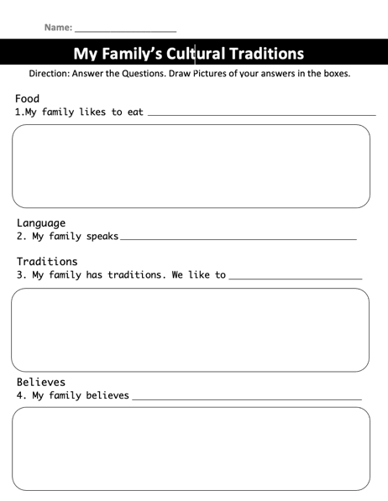 | Materials/Resources:  - White board  - Projector  - Markers  - Worksheet  - Video links  - PowerPoint link  Management/Engagement Strategies:  - Making sure the students are always engaged in the discussions  Safety Considerations

Subject/Grade: Social Studies 2 Lesson Title: How to say HELLO Teacher: Miss Magnusson
Stage 1: Identify Desired Results
Established Goals: (Learning Outcomes)

IN2.2 create a representation of the diversity of cultural groups in the local community.

KUDs  Know: Students will know…  - Students will know how to say hello in 16 different languages | Essential Question(s):  How do you say hello?
Understand: Students will understand (can be written as I Can statements)

- I can say hello in 16 different languages

Do: Students will be able to

- Students will be able to say hello in 16 different languages

Instructional Strategies: (list such as graphic organizers, manipulatives, games, storytelling, etc)

- Videos
- Colouring/drawing

Stage 3: Build Learning Plan
Set (Engagement/hook) Length of Time: 10-15 minutes  Reviewing what we talked about in the last lesson. About culture and traditions and languages.  Do you know any different languages?  Can anyone say hello in a different language. In sign language it is a simple wave.  Wait for anyone that does know and let them have the opportunity to teach it to the class.  Development: Length of Time: 30-40 minutes  Explain to the kids that we are going to be learning how to say hello in different languages.  We will begin by watching this song about 15 ways to say hello. Pay attention to all the different ways people say hello.  Did you notice any ways to say hello in a different language? If so which language?  We are going to watch it again but this time stopping it after every way and practice saying each way to say hello.  Hello around the world song - https://www.youtube.com/watch?v=472AnCrHYVs  - USA – Hello  - Chine – Ni hao  - France – Bonjour  - Japan – Konnichiwa  - Korea – An nyeong  - Italy – Ciao  - Germany – Guten-tag  - Spain – Hola  - UAE – Marhaban  - India – Namaste  - Vietnam – Xin chao  - Thailand – Sawadee Kha  - Russia - Zdravstvuyte  - Kenya – Jambo  - Hawaii – Aloha  - Cree – Tanisi  We will watch the video once all the way through and then we will watch it again stopping every time a new way to say hello is said.  I will also have a poster board with all the words written on them so that students can follow along that way. And can be put up around the classroom.  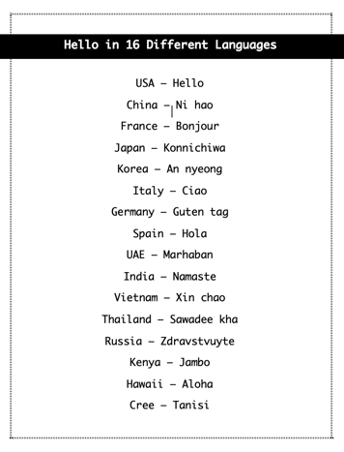  Closure: Length of Time: 10-15 minutes  We are going to draw a picture of the words we just learnt  - Bubble words  - Brick words  - Anything you really want  - Colour them as you wish, anything you want  - Filling the page  Each child will get their own word, some students will have the same words  These can be hung up after they are completed | Materials/Resources:  - Projector  - White board  - Poster board  Management/Engagement Strategies:  - Music  Safety Considerations

Subject/Grade: Social studies 2 Lesson Title: Final Project Teacher: Miss Magnusson
Stage 1: Identify Desired Results
Established Goals: (Learning Outcomes)

Students will understand what they need to complete for their final project.

Stage 2: Determine Evidence by Assessing Learning
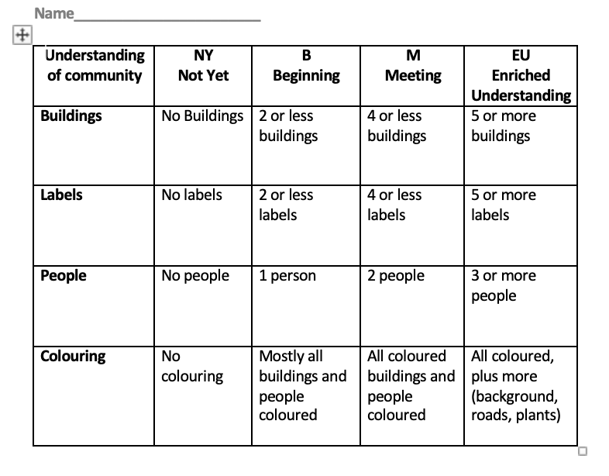

Stage 3: Build Learning Plan
Set (Engagement/hook) Length of Time: 10-15 minutes  Review everything, we have learnt in the unit  - Types of communities  - Roles in a community  - Diverse communities  Development: Length of Time: 30-40 minutes  We are going to start out final project for this unit.  We just reviewed everything we have learnt throughout the unit; we are going to put all of this into action.  For this final project you will be creating a poster of a community.  On this poster you will be required to have  - 3 buildings (house, grocery store, movie theatre, etc.)  - 3 labels  - Colored completely (pencil crayons or crayons)  Through this poster they will show me their understanding of a community.  Let’s go through this step by step.  We are going to start with the buildings. What types of buildings do you think we could put on our poster?  - Houses  - Hospital  - Grocery store  - Movie theatre  - Gas station  - School  Now you need at least 3 buildings on your poster, can you do more yes!  With each building I need a label to tell me what it is. So, if I drew a school, I would label it “school” or St. Jerome. Same with the other buildings. When you label, I need all the buildings labels so I should see 3 labels or more if you want.  Now let’s look at what you’re coloring. I want your entire poster colored. So, what does this mean? Do I want only half of your page colored? No. Do I want none of it colored? No. I want ALL of it colored. So, that means the whole page should be colored and filled in.  Now that we have looked at everything, I want to see in the drawing let’s look at the rubric.  To get an m (meeting). I need to see how many buildings. 3 to 4 buildings. To get an m.  Let’s look at labels, to get an m for this I need to see 3 labels.  Now for coloring, let’s look, I want to see all of the paper colored for with pencil crayons.  You may add in roads if you like, people, and even a background.  Now that we have seen all that we need to complete our final project. I am going to demonstrate what I am looking for.  I will demonstrate everything that I am looking for on the white board and then I will show them my final complete community. On my poster board.  Closure: Length of Time: 10-15 minutes  The students will start to work on their own to complete their poster.  I will walk around the room and make sure everyone is on task.  Asking them to raise their hands when they have a question. | Materials/Resources:  - Paper  - Projector  Management/Engagement Strategies:  - Repeat back to me he instructions  - Making sure everyone is focused on me while going through the rubric  Safety Considerations

